Configuring All Servers in MyEclipse 8.x Environment:-

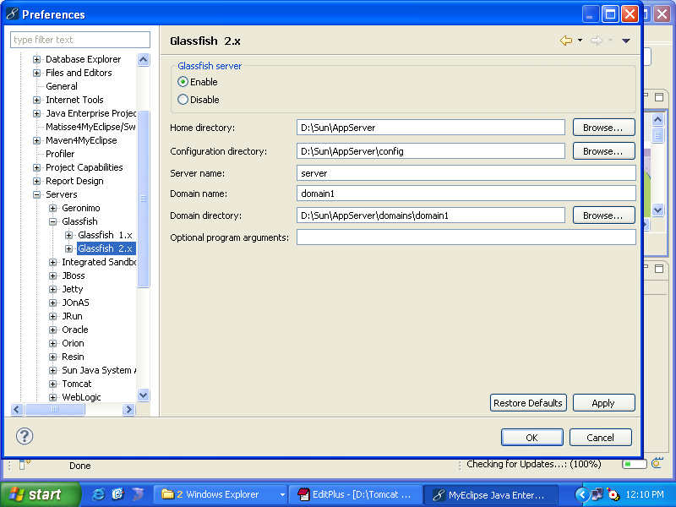

Browser URL:-

http://localhost:4848
username : admin
password : adminadmin
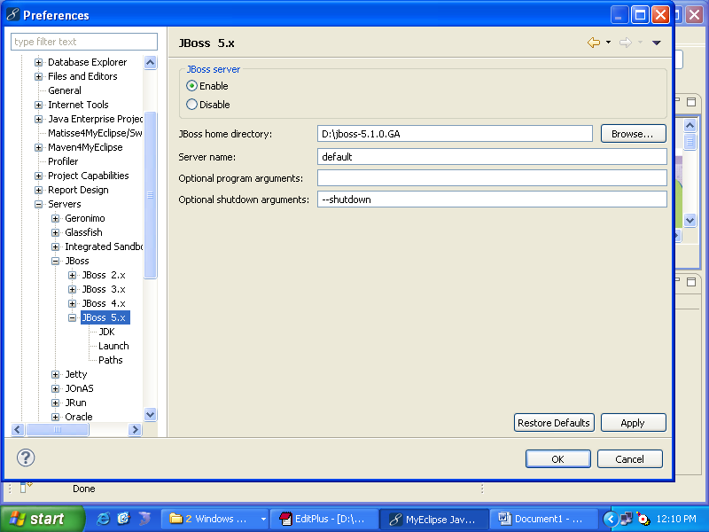

Default port number for JBoss is 8080(but oracle defaults takes), so we have to change the port number for JBoss.
How to Change the port no for JBoss:-

D:\jboss-5.1.0.GA\server\default\deploy\jbossweb.sar\server.xml
Change port 8080 to 65535

Browser URL:-
http://localhost:65535

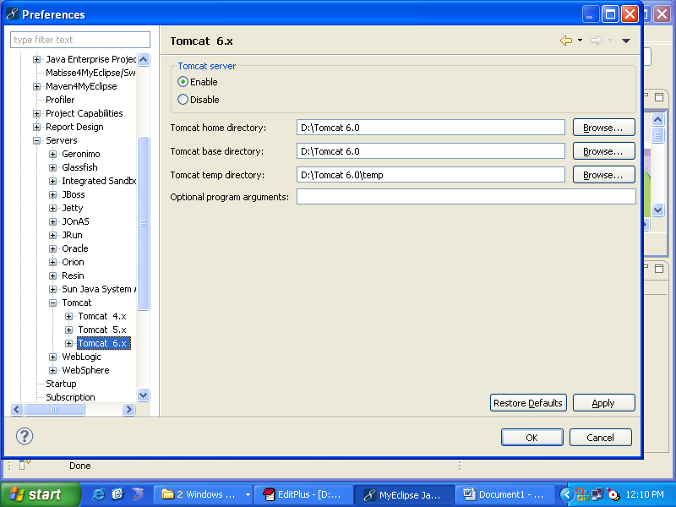

Browser URL:-

http://localhost:2010
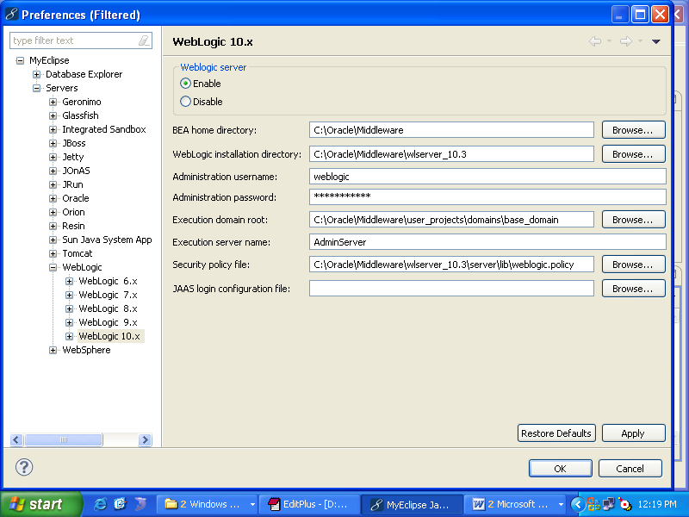

Browser URL:-

http://localhost:7001/console
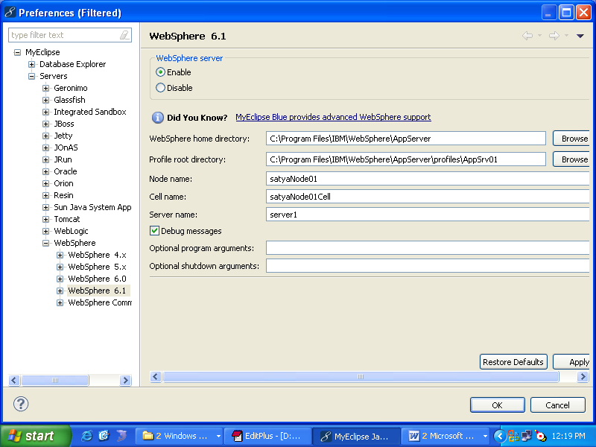

Make sure we have to configure jdk of whatever the jdk came with websphere.
Browser URLs for IBMWebSphere 6.1:-

http://localhost:9060/ibm/console/login.do ----> for to deploy the application.
http://localhost:9080/ApplicationName ------> for to run the application.

For Help(go for online)(Configuring WebSphere6.1 in MyEclipse 8.x , Deploye and Run a Sample Application):-

http://www.myeclipseide.com/documentation/quickstarts/websphere6/

How change the port no:-

C:\Program Files\IBM\WebSphere\AppServer\profiles\AppSrv03\config\cells\satyaNode03Cell\nodes\satyaNode03\serverindex.xml

